Ultimate guide to wrist supports
If you spend long hours at a keyboard—whether for work, study, or everyday computer use—you may have noticed discomfort creeping into your wrists or hands.
This is a common issue, and for many people, a wrist support for typing can make a noticeable difference.
But with so many options available, how do you know which one is right for you? This guide takes you through what wrist supports do, when they’re helpful, and what to look for before buying.


What Is a Wrist Support for Typing?
A wrist support (sometimes called a wrist rest or wrist cushion) is a padded accessory placed in front of your keyboard or mouse. Its purpose is to help keep your wrists in a neutral, comfortable position while you type, reducing strain on the small muscles and tendons in the wrist and forearm.
A good wrist support can provide:
- Gentle cushioning to reduce pressure during pauses in typing
- Improved alignment, helping your wrists stay level rather than bending upwards or downwards
- Support for forearm muscles, reducing fatigue during long computer sessions
- Greater comfort, especially if your desk or keyboard setup is less than ideal
- A more stable typing position, encouraging healthier ergonomic habits over time

Do You Need One? Signs to Look Out For

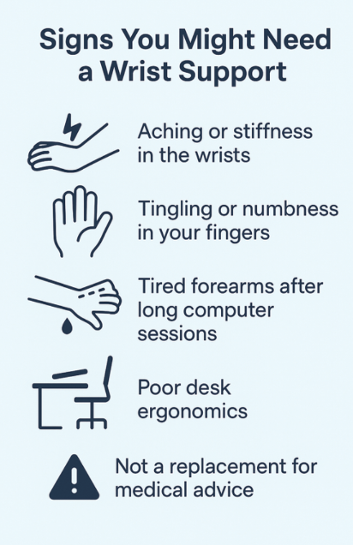
It’s not always obvious when a wrist support might be helpful, especially if discomfort builds gradually over time. However, there are several early warning signs that suggest your typing setup may be putting unnecessary strain on your wrists and hands. Paying attention to these signals can help you prevent minor discomfort from developing into longer-term issues.
You might benefit from a wrist support if you experience:

• Aching or stiffness in the wrists after typing
If your wrists feel sore, tight, or fatigued after even short periods at the keyboard, it may indicate that they’re being held at an awkward angle. A wrist support can help maintain a more neutral position, reducing the strain caused by bending or lifting the wrists while typing.

• Tingling or numbness in your fingers
Sensations like tingling, pins and needles, or mild numbness can be a sign that your nerves are under pressure—often caused by sustained poor wrist posture. While a wrist support won’t diagnose or treat the underlying cause, it can help reduce unnecessary compression and encourage better alignment.

• Tired forearms after long computer sessions
If your forearms feel heavy or exhausted at the end of the day, it may be because the muscles are doing extra work to keep your wrists lifted above the keyboard. Using a wrist support gives your hands a place to rest during pauses, helping to reduce fatigue and improve overall comfort.

• Poor desk ergonomics
You may particularly benefit from wrist support if your workspace isn’t ideally set up—for example:
- A keyboard that sits too high or too low
- A desk with limited depth for comfortable arm positioning
- A chair that cannot be raised or lowered to match your desk height
In these situations, a wrist support can help compensate for less-than-perfect ergonomics and make your setup more comfortable to use throughout the day.

Wrist supports aren’t a cure for pain or injury, and they shouldn’t replace medical advice if you’re experiencing ongoing or severe symptoms. However, they can be a simple and effective way to ease everyday discomfort, promote more natural wrist alignment, and encourage healthier typing habits overall.

Benefits of Using a Wrist Support

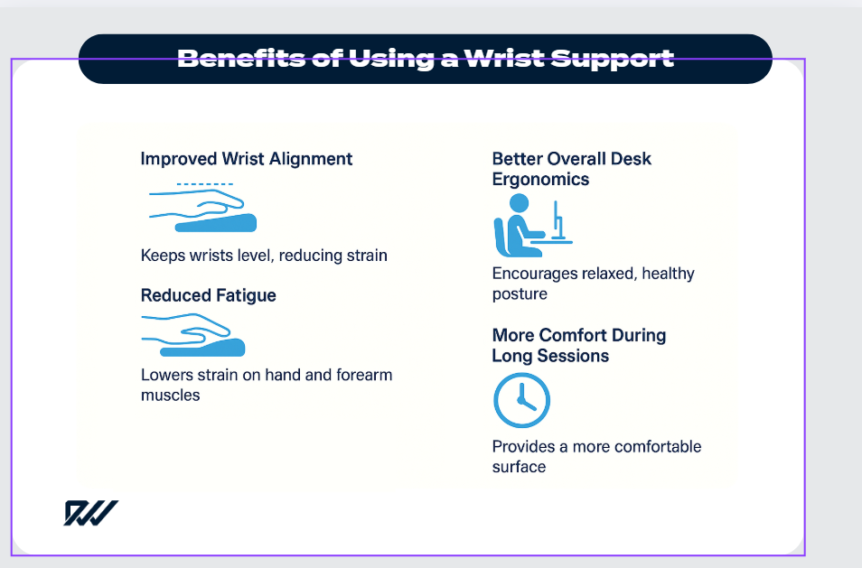

1. Improved Wrist Alignment
One of the key advantages of using a wrist support is maintaining a neutral wrist position. When your wrists stay level—rather than bending upwards towards the keyboard or sagging down towards the desk—it reduces unnecessary strain on tendons, nerves, and small muscles in the hand. Over time, this can help minimise discomfort and lower the likelihood of developing repetitive strain–related issues.

2. Reduced Fatigue
Typing for long periods can place steady pressure on your hands and forearms, especially if they are constantly lifting or hovering above the keyboard. A cushioned wrist support provides a gentle resting spot during pauses, easing tension and reducing overall muscle fatigue. This makes it easier to maintain consistent typing performance throughout the day.

3. Better Overall Desk Ergonomics
A wrist support plays a valuable role in improving the ergonomics of your entire workspace. By positioning your wrists correctly, you also encourage your forearms, shoulders, and upper back to sit in a more natural alignment. This helps prevent slouching, shoulder lifting, and awkward arm positions—issues that can contribute to wider discomfort during long computer sessions.

4. More Comfort During Long Sessions
If you spend hours typing each day—for work, study, gaming, or general computer use—comfort becomes a key factor in your productivity. Wrist supports help cushion the impact of prolonged typing and provide a consistent, comfortable surface to work on. Even minor adjustments in comfort can make a significant difference over time, especially during demanding or repetitive tasks.

5. Support for Inconsistent or Shared Workspaces
If you move between different desks or share a workstation with others, the keyboard height and layout may not always be ideal for you. A wrist support adds a layer of consistency and comfort, helping you maintain better posture even when the setup isn’t fully adjustable. This makes it a practical accessory for hybrid workers, students, and anyone who frequently switches between different computers or locations.



Potential Limitations
Wrist supports can make a noticeable difference to everyday comfort, but it’s important to understand their limitations so you can use them effectively. They are designed to assist good posture and reduce strain—not to replace proper ergonomic habits or address underlying medical issues.
Be aware that:

• Resting your wrists while typing can sometimes increase pressure
Although wrist supports provide cushioning, leaning heavily on your wrists while typing may place extra pressure on the nerves and tissues inside the wrist. This can contribute to discomfort if done incorrectly. Ideally, your wrists should hover slightly during typing and only make gentle contact with the support during pauses or rest breaks. The aim is to encourage a more neutral hand position, not to rely on the pad as a constant anchor point.

• If you have ongoing pain, numbness, or worsening symptoms, seek medical advice
Wrist supports can relieve mild, general discomfort, but they are not designed to treat injuries or persistent symptoms. If you experience continuous pain, tingling, numbness, or symptoms that gradually worsen, it may indicate an underlying issue such as tendon irritation, nerve compression, or repetitive strain. In these cases, consulting a medical professional ensures you receive appropriate assessment and guidance.

• Poor desk height or chair positioning may still cause discomfort
A wrist support can help, but it cannot fix a workstation that is fundamentally misaligned. For example, if your desk is too high, your shoulders may lift; if your chair is too low, your wrists may still bend upwards awkwardly. Without addressing the overall setup—keyboard height, chair adjustment, monitor position—you may continue to experience discomfort, even with a wrist support in place.

While wrist supports can be a valuable addition to your workspace, they work best when used as part of a wider approach to comfort and ergonomics. Paying attention to your overall desk setup, taking regular breaks, and adopting healthy typing habits will help you get the most out of a wrist support. By understanding both their benefits and limitations, you can make a more informed decision and choose the option that genuinely improves your day-to-day typing experience.

Types of Wrist Supports

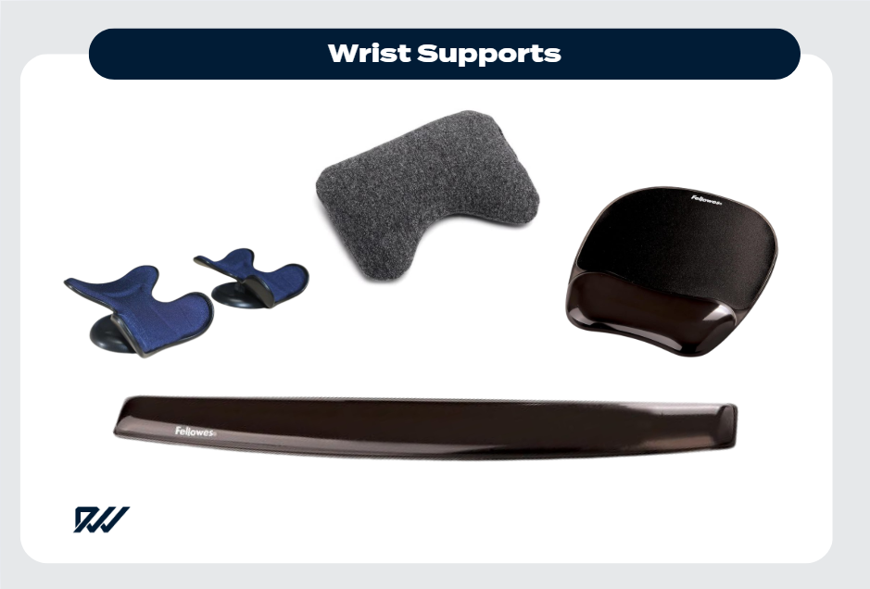
Wrist supports come in several styles, each designed to address different needs depending on how you use your computer. Understanding the main types can help you choose the right option for your workspace and typing habits.

1. Keyboard Wrist Rests
Keyboard wrist rests are long, cushioned pads placed along the edge of your keyboard. Their main purpose is to help keep your wrists level and supported while your fingers move across the keys. They can reduce the strain caused by hovering or bending the wrists upwards during typing. These supports are available in materials such as memory foam, gel, and fabric-covered foam, allowing you to pick a texture and firmness that feels comfortable during extended use.

2. Mouse Wrist Supports
Mouse wrist supports are smaller, individual pads designed specifically for the hand that controls the mouse. Because mouse movements tend to involve more side-to-side motion, these supports focus on reducing friction and preventing awkward wrist angles. They often feature gel or smooth fabric surfaces to encourage natural movement while providing gentle cushioning for the palm or lower wrist area.

3. Ergonomic Keyboard Wrist Pads
Ergonomic wrist pads are shaped to match the curvature of ergonomic or split keyboards. These keyboards often have angled or separated key layouts, so a standard straight wrist support may not provide the right alignment. Ergonomic pads are contoured to ensure your wrists stay in a neutral, comfortable position that complements the keyboard’s design. They are particularly helpful for users transitioning to an ergonomic setup or typing for long periods.

Comparison Table: Choosing the Right Wrist Support
Type of Wrist Support | Best For | Key Benefits | Typical Materials | Considerations
Keyboard Wrist Rest | General typing, office work | Helps keep wrists level; reduces upward bending | Memory foam, gel, fabric-covered foam | Must match keyboard width and height to work effectively
Mouse Wrist Support | Frequent mouse use, design work, gaming | Cushions the wrist during mouse movements; reduces lateral strain | Gel pads, smooth fabric, foam | Should allow free mouse movement, not restrict it
Ergonomic Keyboard Wrist Pad | Users of ergonomic or split keyboards | Provides targeted alignment; supports natural wrist angles | Contoured foam, gel, ergonomic moulding | Only suitable for keyboards with matching ergonomic shapes

Choosing the right wrist support depends on how you work, the equipment you use, and the level of comfort you’re seeking. Each type offers its own benefits, whether you’re looking for general cushioning, improved alignment, or more advanced ergonomic support. By understanding the differences and matching them to your typing habits, you can create a more comfortable, supportive workspace that helps reduce strain and keeps you feeling productive throughout the day.

Other Things to Consider in a Wrist Support

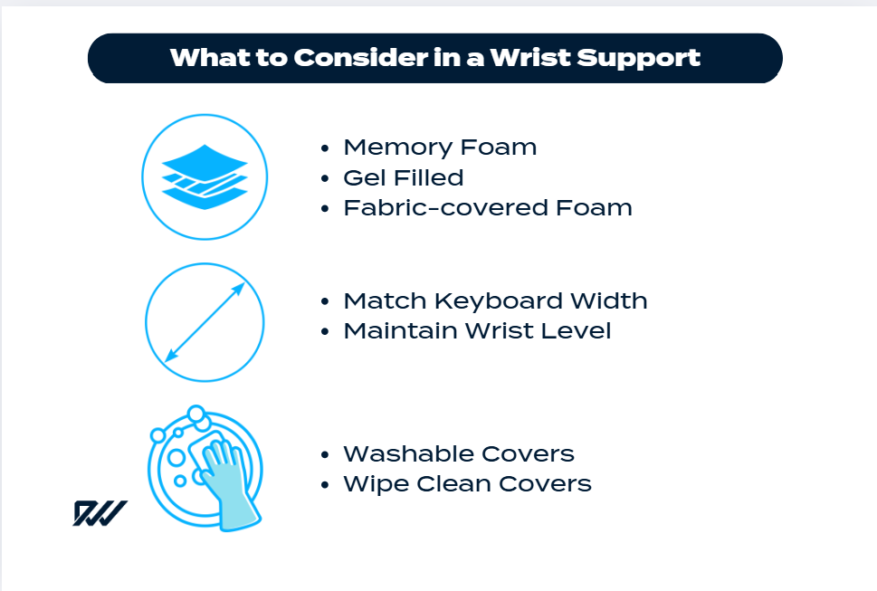
When choosing a wrist support, it’s worth looking beyond the basic shape and deciding which features will give you the greatest comfort and long-term usability.
The following considerations can help you pick a wrist rest that not only feels good initially but continues to support you throughout daily use.

Material
The material plays a big role in both comfort and durability. Common options include:
- Memory foam: Soft, cushioned, and responsive to pressure, memory foam gently moulds to the shape of your wrist. This can offer a personalised feel and excellent comfort during longer sessions.
- Gel-filled: Gel supports tend to feel cooler on the skin and provide a firmer, more stable base. They are ideal if you prefer a little resistance or want something that keeps its shape throughout the day.
- Fabric-covered foam: These offer a balance of comfort and breathability. The fabric layer allows air circulation, helping prevent warmth or stickiness during extended typing periods.

Size and Height
A wrist support should align closely with the size and height of your keyboard. If it’s too tall, it can push your wrists upwards; if it’s too low, your wrists will drop, creating strain.
The ideal support keeps your wrists level with the keys, allowing your hands to move freely without awkward angles. Longer wrist rests also help provide consistent support across the entire keyboard.

Surface Feel
The outer surface determines how your skin interacts with the wrist rest.
Smooth, low-friction materials are best if you frequently shift hand positions, as they help prevent rubbing or irritation.
Some supports feature lightly textured fabrics for added grip, while others use silk-like covers for a softer feel.

Non-slip Base
A non-slip bottom helps keep the wrist support securely in place, ensuring it doesn’t slide across your desk while typing or when adjusting your keyboard.
This is especially important for users with glass or polished surfaces, where movement can be more noticeable.

Ease of Cleaning
Since wrist supports are used daily, choosing one that’s easy to clean will keep it looking and feeling fresh. Some come with removable, washable covers, while others feature wipe-clean, water-resistant surfaces.
This can be particularly useful if you snack or drink at your desk or share equipment in a communal workspace.
ADD WRIST SUPPORT CHECKIST

Ergonomic Tips When Using a Wrist Support

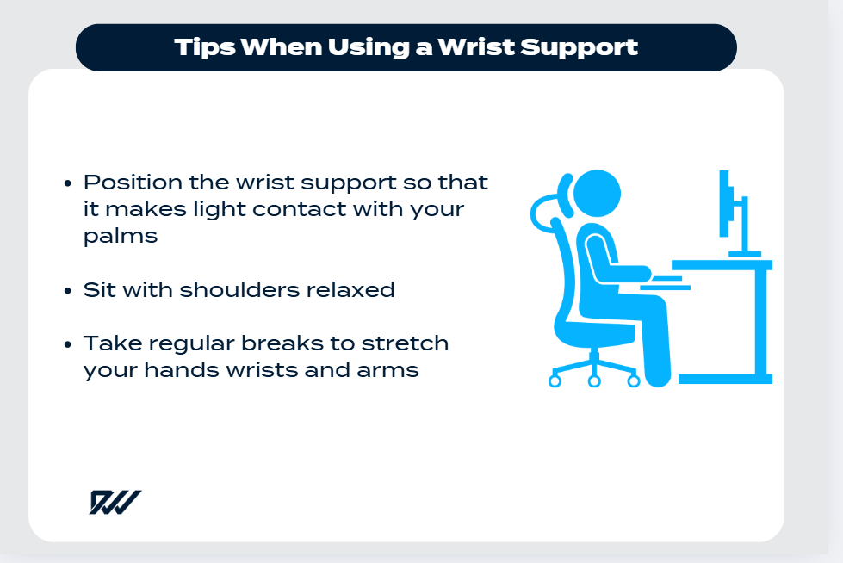
Using a wrist support can make typing more comfortable, but how you position it—and how you sit—plays a big role in how effective it will be. These ergonomic tips will help you get the most benefit from your wrist rest and support healthier posture throughout the day.

• Keep your keyboard at elbow height
Your keyboard should sit level with your elbows so your forearms can stay parallel to the floor.
If the keyboard is too high, your shoulders may lift and your wrists may tilt upwards; if it’s too low, your wrists may drop and your hands may angle awkwardly. Adjust your chair or desk if needed to create a natural, relaxed typing position.

• Position the wrist support to make light contact with your palms—not your wrists—while typing
A common mistake is using a wrist rest as a place to lean heavily while typing. Instead, the support should be positioned so that it only touches the base of your palms during pauses in typing.
This helps you maintain neutral wrist alignment and prevents unnecessary pressure on the wrist joints.

• Sit with shoulders relaxed and feet flat on the floor
Good posture starts from the ground up. Keeping your feet flat on the floor (or on a footrest if needed) stabilises your body and helps prevent slouching. Relaxing your shoulders and keeping them down—not hunched toward your ears—reduces neck and upper back tension, which can also influence how your wrists and arms feel during typing.

• Take regular breaks to stretch your hands, wrists, and arms
Even with an excellent ergonomic setup, it’s important to give your muscles a chance to rest. Short, frequent breaks help prevent stiffness and improve circulation.
Simple stretches—such as rotating your wrists, gently pulling back your fingers to stretch your forearm muscles, or shaking out your hands—can make a noticeable difference in comfort.

Should I Buy a Wrist Support?


Deciding whether to buy a wrist support largely depends on how you feel during and after typing. If you regularly notice wrist discomfort, tension, or fatigue, a wrist support can be a simple and affordable addition that makes a noticeable difference to your daily comfort.
It’s designed to encourage a more neutral wrist position, reduce strain, and provide cushioning during pauses in typing—small benefits that can add up over time.
However, it’s important to remember that a wrist support is most effective when used alongside other good ergonomic habits. Proper desk height, a supportive chair, relaxed posture, and regular movement all play a key role in keeping your hands and arms comfortable. A wrist rest can complement these habits, but it won’t replace them.
For many people, adding a wrist support is a small, low-cost change that contributes significantly to long-term comfort.
It can help prevent early signs of strain from developing into more persistent issues and make extended typing sessions feel much easier on your hands and arms.
If you’re looking for a simple way to improve your workspace, a wrist support is often a worthwhile investment.

Conclusion
Choosing the right wrist support can be a small but meaningful step towards creating a more comfortable, ergonomic workspace.
Whether you’re typing for work, study, or leisure, the right support can help promote healthier wrist alignment, reduce everyday strain, and make long computer sessions more manageable.
While a wrist support is not a cure-all, it works best when paired with good posture, sensible desk habits, and regular breaks.
By understanding the different types available and the features that matter most, you can make an informed decision that supports your long-term comfort and wellbeing.

Key Takeaways
- Wrist supports help improve wrist alignment, reducing pressure on tendons and nerves.
- Different types suit different needs, from keyboards and mice to ergonomic setups.
- Material matters—choose between memory foam, gel, or breathable fabric depending on your comfort preferences.
- A good ergonomic setup is essential, as wrist supports work best when combined with proper posture and desk height.
- Look for practical features such as a non-slip base, suitable height, and easy-clean surfaces.
- Wrist supports are a low-cost improvement that can make long typing sessions more comfortable and reduce strain over time.

